Congressional Serial Set
Hidden Treasures in American History

Harlan Hatcher Graduate Library
The University of Michigan
December 2005

General Parameters

Purpose:

- Celebrate purchase of digital Serial Set and encourage campus use by illustrating the variety of information available

Themes:

- Early American History
- Great Explorations
- War
- Social Conditions
- Civil Rights
- Technology
- Serial Set Today
- Accessing the Serial Set

Cases:

- Six cases: 1-4, 7-8 approximately 67” wide by 57” long
- Two cases: 5-6, approximately 28” wide by 57” long
- Black felt background; white text; navy or plum backing

Examples:

- Chosen based on a combination of reference experience, a knowledge of American history, the Encyclopedia of American History, and a speech by Ann Sanders of the Library of Michigan on October 9, 2005
- Primarily used LEXIS Congressional to identify the appropriate volumes but retrieved the paper from storage to choose illustrations

Illustrations:

- Some illustrations were color-xeroxed from Serial Set volumes when they were essential to the point of the text (e.g. pictures of birds or lighthouses)
- When they were tangential, we first surveyed the National Archives site for possibilities before going to a more general internet search.
- In-library pictures were taken with a digital camera, and screen shots were captured using Snag-It.
- All digital pictures were run off on 8x10 or 4x6 glossy photo paper

Physical Volumes:
- About half of the pre-1920 physical volumes were too delicate to display. In those cases we either substituted a commercial edition or a Xeroxed copy
- Pages were held open with a heavy mylar tape

Banners:
- Created using Print Shop 6.0 and a color printer at home using regular 8-1/2 x 11 paper subsequently glued together
- Width was limited to two 11” sheets because wider banners were being obscured by the three case doors

Brochure:
- General template from the Michigan Depository Library
Council modified for the purpose
- Attached

CASE 1: Congressional Serial Set – Hidden Treasures in
American History

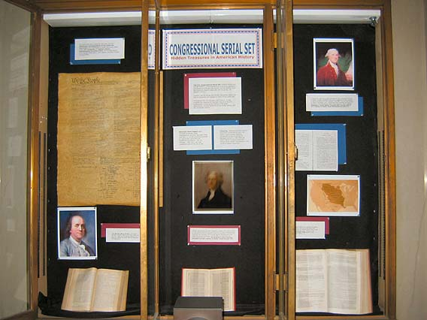

Center

The U.S. Congressional Serial Set contains House and Senate Reports (recommendations on pending legislation) and House and Senate Documents (communications from the Executive Branch) since the 15th Congress, 1st Session (1817).

Lawyers use the House and Senate committee reports on bills to determine the legislative intent of any given law.

Throughout the 19th and early 20th Century, it also included the majority of important Executive Branch publications, including the reports of the great explorations, Foreign Relations of the United States, and the Decennial Census.
American State Papers were privately produced under congressional authority between 1832 and 1861 to include previously printed or manuscript executive and legislative documents. The 38 volumes, 1789-1823, are also considered part of the Serial Set.

Indexing. Although printed indexes have been published for over 100 years, computerized indexing introduced to the University of Michigan campus in Fall 2005 via LEXIS-NEXIS Congressional and Google Book Search has opened a new world of hidden treasures.

Object: Color photo of Thomas Jefferson painting
Jefferson used excerpts from New Testaments in Greek, Latin, French & English to create parallel columns of text recounting the life of Jesus, preserving what he considered to be Christ's authentic actions and statements, eliminating the mysterious and miraculous. He eliminated Gabriel’s announcement of the Virgin Birth and the Resurrection. His 1820 Bible was reprinted in the Congressional Serial Set in 1904. Life and Morals of Jesus of Nazareth. Document 4747 (58th Congress, 2d session., House Document 755)

Object: Document 4747 (58th Congress, 2d session., House Document 755)

Left

Object: Reproduction of the Declaration of Independence purchased from the National Museum of American History
The Serial Set had a relatively late start, but the Diplomatic Correspondence of the American Revolution was republished in 1888. Document 2584-2589 (50th Congress, 1st session, House Miscellaneous Document 603). In includes letters from George Washington, John Adams, and Ben Franklin among others.

Object: Picture of Benjamin Franklin

“You just don’t get it, do you?” is the tone of Benjamin Franklin’s letter to Lord Howe, dated July 20, 1776. Howe was still offering pardons to the American colonists two weeks after the Declaration of Independence.

Object: Document 2585, p. 103

Right

Object: Picture of George Washington
On August 20, 1894, the Congress authorized the Joint Committee on Printing to create a complete compilation of the annual, inaugural, and veto messages as well as proclamations of the Presidents, 1789-1894. The work was compiled by James D. Richardson, then a representative from Tennessee and issued as A Compilation of the Messages and Papers of the Presidents. Below is George Washington’s farewell address. Document 3265-1 through 3265-12 (53rd Congress, 2d Session, House Miscellaneous Document 210)

Object: Photocopy of Washington’s farewell address

Object: General map of the Louisiana Purchase territory

In 1803 Thomas Jefferson and Napoleon Bonaparte signed a treaty in which the United States paid France $15 million for 828,000 square miles of land west of the Mississippi River. The text of the Louisiana Purchase Treaty appears in the American State Papers, v. 2.

Object: American State Papers, Class 1, v. 2, P. 507

CASE 2: Great Explorations in the Serial Set

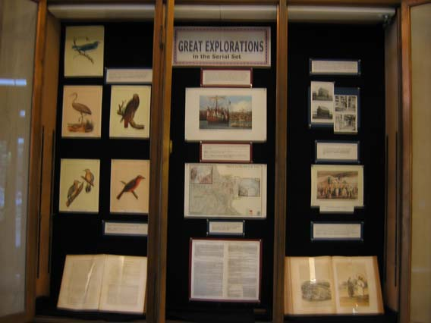

Center
Shortly after the Louisiana Purchase, President Jefferson requested Congress to fund an expedition by Meriwether Lewis and William Clark to travel westward, creating maps and documenting the animal species and plants they discovered, and describing Native American culture. In a three-year period beginning 1804 they traveled over 3700 miles along the Missouri and Columbia Rivers over what would become 11 states.

Object: Color Xerox: Painting of Departure from St. Charles, Missouri

Manuscripts from the Lewis and Clark Expedition have been published commercially.

Above: Departure from St. Charles, Missouri.
Below: La Charrette to St. Louis

Both from Atlas of Lewis and Clark in Missouri by James D. Harlan and James M. Denny. Courtesy of Map Library.

Object: Color Xerox of map, La Charrette to St. Louis

Brief reports describing Native American tribes and the weather were issued in the American State Papers, Indian Affairs, Class 2, Volume 1, Document 113.

Object: Xerox of American State Papers, Indian Affairs, Class 2, Volume 1, Document 113, p. 706-707

Left
The early explorations documented botany, zoology, and geology as well as Native American tribes. Naturalists accompanied the Army topographers seeking various routes for the transcontinental railroad, 1853-55. Their reports appeared as Document 758-768 (33rd Congress, 2d Session, Senate Executive Document 78) and included color plates.

Object: Color Xerox of Document 767, Plate XXXV, Arctic Bluebird

Object: Color Xerox of Document 767, Plate XXXVII, Little Crane

Object: Color Xerox of Document 767, Plate XIV, Red-Tailed Black Hawk

Object: Color Xerox of Document 767, Plate XXXVI, Gila Woodpecker

Object: Color Xerox of Document 767, Plate XXXI, Swainson

Above: brightly-colored birds from Document 767.

Below: description of the Ursus Horribilis, or grizzly bear, from Document 765, p. 219 ff.

Object: Document 765, p. 219

Right

Captain W.R. Abercrombie of the U.S. Infantry was sent to explore a military route through central Alaska in 1899, two years after the Alaska gold rush had begun. His report not only covers geology of the region but how Alaskan women dress, the liquor traffic in Valdez, and what it feels like to work at -65 degrees F.

Object: Xerox of two black and white photos of the scurvy hospital
In Valdez, Document 3874
The expedition’s report includes numerous black and white photographs. Illustrated: the Scurvy Hospital for Destitute Miners at Valdez. Document 3874, 56th Congress, 1st Session, Senate Document 306.

Object: Color Xerox of Perry’s Delivery of Gifts at Yokohama

Commodore Matthew Perry left Norfolk in November 1852 to thaw Japan’s isolationist policy. His itinerary included Madeira, St. Helena, Capetown, Mauritius, Singapore, Hong Kong, Shanghai, and Okinawa. In every port Perry and his officers wrote voluminously of peoples, customs, commerce and science. His expedition led to the Convention of Kanagawa in 1854. A description of his journeys appears in Documents 802-804 (33rd Congress, 2d Session, House Executive Document 97).

Object: Document 802, pp. 226-227

CASE 3: War in the Serial Set

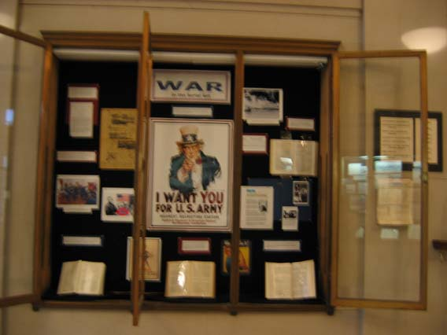

Center
Uncle Sam’s “I Want You” poster was created by James Montgomery Flagg for the cover of Leslie’s Weekly, July 6, 1916. It was used for recruiting in both World Wars I and II.

Object: “Uncle Sam Wants You” poster purchased from National Museum of American History

Congressional committee hearings were occasionally published in the Serial Set until the 1920s but are now completely separate publications. Below is a hearing on the treaty with Germany following WWI. Document 7605 (66th Congress, 1st Session, Senate Document 106)
Object: Document 7605 (66th Congress, 1st Session, Senate Document 106), p. 254-255

Object: To left, a World War I poster run off on 8x11 photo paper
http://afsf.lackland.af.mil/Images/WWI/pages/WWI%20US%20Food%20Admin_jpg.htm

Object: To right, a “We Can Do It” mouse pad purchased from National Museum of American History

Left
Genealogists often use the private claims made by Civil War participants to Congress for writing their family histories. This claim was made by Sarah A. Monroe for her husband, who died after serving as a chaplain for the Union Army.

Object: Document 1240 (39th Congress, 1st session, Senate Report 123), as run off from LEXIS

Object: Battle of Gettysburg Map, purchased from National Museum of American History

War of the Rebellion: A Compilation of the Official Records of the Union and Confederate Armies is a 128-volume compilation of war operations and correspondence that was published in the Serial Set over a number of years. It has also been digitized by the Making of American Project: http://cdl.library.cornell.edu/moa/browse.monographs/waro.html
Object: Color printout of Grant and Lee from the web.

Object: Color printout of Lee’s Surrender at Appomatox from the web.

General George Meade reports the killed, wounded and missing from the Battle of Gettysburg (July 1-3, 1863) in this commercial reprint of Document 2771 (51st Congress, 1st session, H.misdoc. 146)

Object: Document 2771 (51st Congress, 1st session, H.Mis.Doc. 146)
pp. 112-113

Right

Object: Copy of a black and white photo of Pearl Harbor under attack run off from web.

Object: Naval Communique from December 7, 1941 run off the web
The Joint Congressional Committee on the Investigation of the Pearl Harbor Attack completed its report in 1946. Document 11033 (79th Congress, 1st session, Senate Document 106)

Object: Document 11033 (79th Congress, 1st session, Senate Document 106) This was light enough that it could be attached to the back of the case with mylar.

Object: 2 black and white photos of anti-Vietnam teach in.

Object: Michigan Today, October 1995 –
http://www.umich.edu/~newsinfo/MT/95/Oct95/mt11o95.html

A Senate report, Anti-Vietnam and Teach-in Movement, p. XI, attributes the start of the teach-in movement to the University of Michigan. Document 12668-2 (89th Congress, 1st session, Senate Document 72 ).

Object: Document 12668-2 (89th Congress, 1st session, Senate Document 72 ), p. XI

CASE 4: Social Conditions in the Serial Set

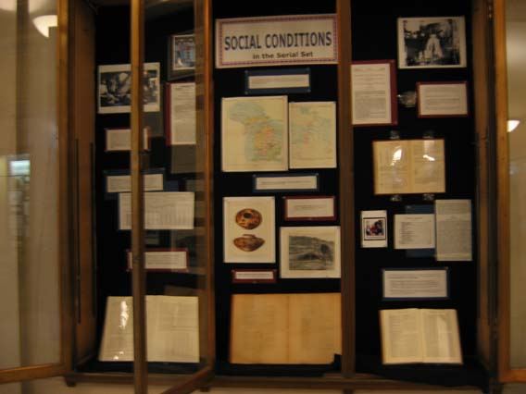

Center
The Smithsonian Institution’s Bureau of Ethnology published its annual reports and special papers on Native Americans in the Serial Set from the 1880s to 1920s.

Object: 2 color Xeroxes of maps of Indian land cessions in Michigan.
Document 4015 (56th Congress, 1st Congress, House Document 736/3).

Object: 2 Xeroxes, one of Native American pottery (color) and one of a Navajo summer home (black and white). Document 3837 (55th Congress, 3rd Session, House Document 316).
Indian Land cessions in Michigan. Document 4015 (56th Congress, 1st Congress, House Document 736/3).

Navajo summer home and Native American pottery. Document 3837 (55th Congress, 3rd Session, House Document 316).

Object: Dakota-English Dictionary, Document 2979
(52nd Congress, 1st Session, House Document 26).

Left

Object: Color 4x6 photo of women working at Colonial Williamsburg.

Object: Black and white photo for a 10-year-old boy in a factory.

The Keating-Owen Act (September 1, 1916), which barred products of child labor from interstate commerce, was ruled unconstitutional, and the Child Labor Amendment of 1924 was never ratified by the states. However, children under 16 were forbidden from labor by the Fair Labor Standards Act of 1938, which was ruled constitutional. Report on the Child Labor Amendment to the Constitution: Document 8221 (68th Congress, 1st Session, Senate Report 406).

Object: Xerox of Report on the Child Labor Amendment to the Constitution: Document 8221 (68th Congress, 1st Session, Senate Report 406).
The 1890 Census included numerous personal questions about physical health, mental health, and poverty. The volume entitled Crime, Pauperism and Benevolence provides data on residents in almshouses by sex, race, and reasons for admission, including tramps, the elderly, and syphilitic. Document 3029 (52nd Congress, 1st Session, House Miscellaneous Document 340/22)

Object: Xerox blown up 125% of size of Table 233, assigned reasons for being in almshouses, of Document 3029 (52nd Congress, 1st Session, House Miscellaneous Document 340/22)

The 1880 Decennial Census published unique histories of large cities in
the United States. Detroit was considered a Western city at the time. Its description back to August 11, 1669 and include 1880 estimates of street and alley mileage, gallons of water pumped, city parks, and internment in cemeteries. : Reprint of Social Statistics of Cities, v. 2, 1880 Census. Document 2149, 47th Congress, 1st Session, House Miscellaneous Document 42/21)

Object: Document 2149, 47th Congress, 1st Session, House Miscellaneous Document 42/21), pp. 606-607, showing mileage of streets and alleys in Detroit.

Right

Object: Black and white printout of Detroit police raiding a still. From the web.

Object: Document 9647 (72nd Congress, 2nd Session, Senate Report 1105)

Object: Whiskey glass celebrating 2001 Presidential Inauguration, purchased as souvenir in Washington, D.C., January 2001. Secured with Velcro and mylar.

Prohibition of alcohol, instituted by the 18th Amendment (1920) was repealed by the 21st Amendment to the Constitution on December 5, 1933.

Above: Detroit Police raid a still.

Far Left: Report on modification of the National Prohibition Act and establishment of liquor taxes.
Document 9647 (72nd Congress, 2nd Session, Senate Report 1105)

Left: Shot glass commemorating the inauguration of President George W. Bush, January 2001.

The Dillingham Commission, 1907-1910, was authorized by Congress to fully examination immigration to the United States. Its 41 volume report includes a Dictionary of Races and Peoples, a statistical review of immigration, 1819-1910, immigrants in cities and specific industries, even the importation of women for immoral purposes. It was published as Serial 5663-5684/3 and 5865-5881. A second copy is located in the Graduate Library stacks as: JV 6415 .A3

Object: 4x6 color photo of 32-cent “immigrants arrive” stamp

Object: Emigration Conditions in Europe, Document 5870 (61st Congress, 3rd session, Senate Document 748), p. 241

Object: Importation and Harboring of Women for Immoral Purposes, Document 5877 (Senate Doc. 753/2, p. 53) This volume was being digitized. Used printout from The Making of Modern Law (http://galenet.galegroup.com/servlet/MOML?af=RN&ae=F152705365&srchtp=a&ste=14&locID=umich_law

Dictionary of Races and Peoples is an encyclopedic classification of the world’s cultures. It is available as Document 5867 and digitized by the UMich Making of America Project as http://name.umdl.umich.edu/AFL0168.0001.001.

Object: Document 5867, Dictionary of Races and Peoples

CASE 5 – Serial Set Today

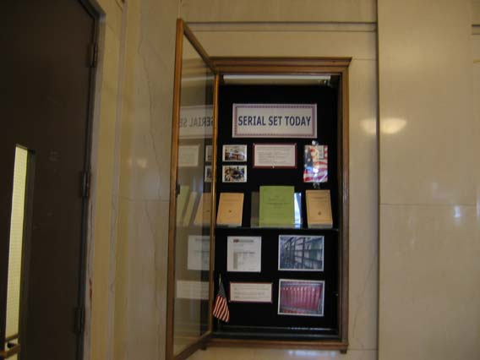

Only a handful of Executive Branch documents, such as the State of the Union message, Federal Budget, and Economic Report of the President are issued in the Serial Set today.

Today’s Serial Set is primarily composed of
Reports on Legislation - Medicare Prescription Drug Benefit (House Report 108-391)
Reports of Investigations – PreWar Intelligence Assessments in Iraq (Senate Report 108-301)
Publicity Pieces – Our Flag
(Senate Document 105-13)
Internal Working Documents – Statement of Disbursements of the House (House Document 109-19)

Objects: 4x6 color pictures of soldier in Iraq and pharmacist

Object: Our Flag (Senate Document 105-13)

Objects: Books on Glass Shelf in Middle:
- House Report 108-391 (Medicare Prescription Drug Benefit)
- Senate Report 108-301 (Pre-War Intelligence Assessments in Iraq
- House Document 109-19 (Disbursements of House)

Additional sources of Congressional Information include:

Bills – Accessible through THOMAS: http://thomas.loc.gov/ (above)

Hearings – Indexed in LEXIS-NEXIS Congressional - http://web.lexis-nexis.com/congcomp/ (upper right)

Debates – in the Congressional Record – Stacks J 11.R and LEXIS-NEXIS Congressional, 1985+ (right)

Objects:

- 8-1/2x11 screen shot of Thomas (http://thomas.loc.gov/)
- Digital photo of Congressional hearings in Documents Center
- Digital photo of bound Congressional Record

Object: Small American flag purchased at party store

CASE 6 – Accessing the Serial Set

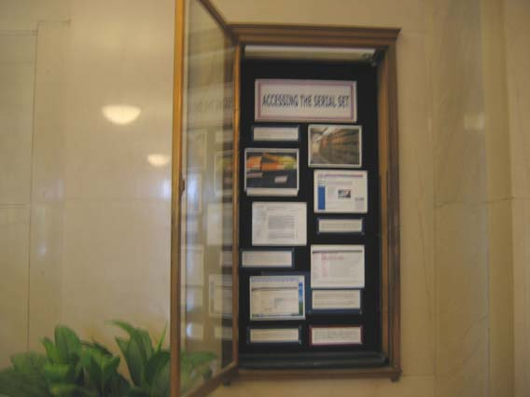

Printed copies of the Serial Set are located in Buhr (Document 1-7915, 1817-1921), Graduate Library Stacks on 1 East (7916-14801, 1921-2002), and 2003+ in the Documents Center.

Object: 8-1/2x11 digital photo of Serial Set in Stacks

Object: 8-1/2x11 digital photo of Serial Set microfiche
The Documents Center has microfiche copies for all years

Object: Large screen capture of GPO Access, http://www.gpoaccess.gov /serialset/index.html

The Government Printing Office web site, GPO Access (http://www.gpoaccess.gov /serialset/index.html) indexes and provides the full text of all Serial Set publications in pdf format beginning with the 104th Congress, 1995.

Objects: Screen shots of the main screen and full text screen of Lexis-Nexis Congressional. http://web.lexis-nexis.com/congcomp
LEXIS-NEXIS Congressional <(http://proxy.lib.umich.edu/login?url=”http://web.lexis-nexis.com/congcomp”) has been indexing the historical serial set (in Historical Indexes) and current issues (in CIS Index) for several years.

The University of Michigan Library purchased the Historic Full Text of the Serial Set, 1789-1969 in Fall 2005.

Object: Screen print of Google Book Search (http://books.google.com/) showing Defense Production Amendments of 1955.
GOOGLE BOOK SEARCH (http://books.google.com/) will be adding copies of Serial Set documents to its database as it digitizes the Michigan and Stanford collections over the next five years. As of November 2005 it includes references to Serial Set materials found in Congressional committee hearings

For further information about Congressional publications, contact the Documents Center in person (2nd Floor, Hatcher Library North), by telephone (734-764-0410), or E-Mail (govdocs@umich.edu)

Exhibit Curator: Grace York, Documents Center, with very special thanks to Frank Lester and Catherine Morse of the Documents Center; Sarah Cookingham, Collection Marketing Assistant; Donna Heiden of Library Photoduplication; Graduate Library Circulation Staff, and Buhr Shelving Facility Staff.

CASE 7: Civil Rights in the Serial Set

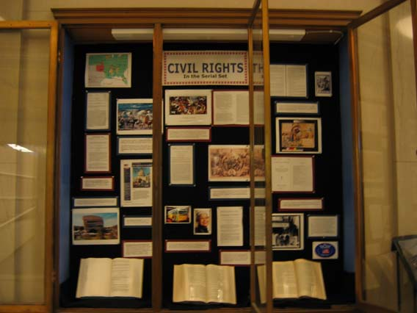

Center
Fifty Africans, who were seized against international law by Spain, revolted on the ship Amistad. They themselves were seized by a U.S. brig in 1839 and freed by the Supreme Court in 1841. The following document from President Martin Van Buren, dated April 15, 1840, transmits to Congress the correspondence between the Spanish and American governments. Document 366 (26th Congress, 1st session, House Document 185)

Object: Color print of Amistad drawing from the web

Object: Photocopy of Document 366 (26th Congress, 1st session, House Document 185)
Although the Emancipation Proclamation was effective for the Confederacy on January 1, 1863, slavery was official abolished by the 13th Amendment, ratified on December 6, 1865. Senate Report on the 13th Amendment. Document 1239 (39th Congress, 1st session Senate Miscellaneous Document 1)

Object: Color print of graphic showing Lincoln and slaves.

Object: Photocopy of Document 1239 (39th Congress, 1st session Senate Miscellaneous Document 1)

Civil rights pioneer, Rosa Parks, refused to give up her bus seat to a white man in Montgomery, Alabama on December 1, 1955. House Report 109-193 recognizes the 50th anniversary. Mrs. Parks passed away on October 24, 2005 and was the first woman to lie in honor in the Capitol Building.

Objects: 4x6 color prints of Rosa Parks and Montgomery bus from the web.

Object: House Report 109-193
When the 15th Amendment proved insufficient in the South, Congress passed a Voting Rights Act that prohibited the denial or abridgment of the right to vote by African Americans on a nationwide basis. Lyndon Johnson signed the law on August 6, 1965. Document 12665-3 (89th Congress, 1st session House Report 439)

Object: Document 12665-3 (89th Congress, 1st session House Report 439)

Left
The United States concluded 371 treaties with Indian tribes between 1787 and 1868. They usually guaranteed peace, a clarification of boundaries, and Indian hunting and fishing rights.

The Treaty of New Echota, signed in 1835, allowed the U.S. government to export the Cherokee of Georgia to Oklahoma. The result was the “Trail of Tears” in which 4,000 Cherokee died. Document 315 (25th Congress, 2d session, Senate Document 121).

Object: Color map of the trail of tears from the web

Object: Color photo of the painting “Trail of Tears”
Congress extended citizenship and voting rights to all Native Americans who wanted it in 1924 as a result of their service in WWI. Document 8221 (68th Congress, 1st session, Senate Report 441).

Object: Document 8221 (68th Congress, 1st session, Senate Report 441).
Ben Nighthorse Campbell was the first Native American elected to Congress. He served in the Senate from 1993 to 2004.

Object: Color printout of Senate Campbell’s archived web site, http://web.archive.org/web/20010924005412/http://campbell.senate.gov/
The National Museum of the American Indian was authorized by Public Law 101-185 (1989) and opened in 2004. Document (101st Congress, 1st Session, House Report 340/pt.1).

Object: Picture of Museum downloaded from a Smithsonian web site
The Native American Graves Protection and Repatriation Act (NAGPRA) of 1990 provides a process for museums and Federal agencies to return certain Native American cultural items -- human remains, funerary objects, sacred objects, and objects of cultural patrimony - to lineal descendants, culturally affiliated Indian tribes, and Native Hawaiian organizations. Document (101st Congress, 1st Session House Report 101-877.

Object: Document (101st Congress, 1st Session House Report 101-877.

Right

Object: Print of black and white poster on women the election day from 1902.

Object: Photocopy of Document 6365 (62nd Congress, 3rd Session, Senate Document 1035), p. 6-7

The woman suffrage amendment was introduced in 1878 and went unchanged until 1919. It was ratified by the states as the 19th Amendment in 1920. The compilation above includes hearings from 1880, 1884, and 1912. Reports and Hearings on Women Suffrage: Document 6365 (62nd Congress, 3rd Session, Senate Document 1035)

Object: Color print of Official Program, Woman Suffrage Procession, March 3, 1913 from the web

Object: Photocopy of table of contents: Argument Against Woman Suffrage: Document 6952 (64th Congress, 1st session, Senate Document 408)

The National Anti-Suffrage Association requested Paul Dillingham, who chaired the Immigration Commission, to introduce its report against suffrage. Argument Against Woman Suffrage: Document 6952 (64th Congress, 1st session, Senate Document 408).

Object: Printout of National Anti-Suffrage Association black and white photo

The Equal Rights Amendment was introduced into every Congress between 1923 and 1972, when it finally passed Congress. However, by 1982 only 35 or the necessary 38 states had ratified it – Alaska, California, Colorado, Connecticut, Delaware, Hawaii, Idaho, Indiana, Iowa, Kansas, Kentucky, Maine, Maryland, Massachusetts, Michigan, Minnesota, Montana, Nebraska, New Hampshire, New Jersey, New Mexico, New York, North Dakota, Ohio, Oregon, Pennsylvania, Rhode Island, South Dakota, Tennessee, Texas, Vermont, Washington, West Virginia, Wisconsin, Wyoming. Document 12971-1 (92nd Congress, 2nd Session, Senate Report 92-689).

Object: Small ERA banner.

Object: Document 12971-1 (92nd Congress, 2nd Session, Senate Report 92-689).

CASE 8: Technology in the Serial Set

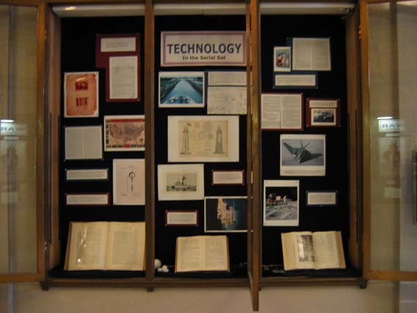

Center

Frenchman Ferdinand de Lesseps, who built the Suez Canal, attempted to build a canal in Panama but bad management, nature, and disease led him to abandon it.
In 1904 Panama granted the United States the right to build a canal and control the area on five miles of either side. The chief engineer of the U.S. Isthmian Canal Commission was John F. Stevens. The canal was complete on August 15, 1914. The Annual Report of the Governor, 1915, includes a diagram of a dry dock. Document 6982 (64th Congress, 1st session, H.doc.23)

Object: Color print of ship going through the Panama Canal from the web.

Object: Photocopy of drawing from Annual Report of the Governor of the Panama Canal, 1915, Document 6982 (64th Congress, 1st session, H.doc.23)

Sea coasts, lakes, rivers and harbors are considered crucial to the national defense. Reports from the Secretary of War and Army Corps of Engineers have included drawings of lighthouses and assessments of potential hurricane damage. Document 2685 (51st Congress, 1st Session, Senate Executive Document 56).

Object: Photocopy of Minot’s Ledge Lighthouse from 2685 (51st Congress, 1st session S.exdoc.56).

Object: Photocopy of Detroit River Light House from 2685 (51st Congress, 1st session S.exdoc.56).

The Senate Commerce Committee began hearings on the Titanic on April 19, 1912, just five days after the ocean liner sank in the Atlantic. The purpose was to determine whether regulations on the number of lifeboats, ship size, and ocean routes should be issued. Titanic Disaster: Document 6167
(62nd Congress, 2nd Session, Senate Document 726).

Object: Color print of sunken Titanic from the web.

Object: Titanic Disaster hearings, Document 6167
(62nd Congress, 2nd Session, Senate Document 726).

Left
Eli Whitney patented the cotton gin on March 14, 1794 to separate cotton from its seeds. In the letter below he requests that his patent be extended beyond 13 years.

Object: Color print of cotton gin patent from: http://www.archives.gov/education/lessons/cotton-gin-patent/

Object: Photocopy of application for extension of cotton gin patent, ASP 38, Misc. 319, 1811-1812 1 page.

Object: Color print of Union Pacific Railroad route from the web.

Object: Photocopy of Document 1124 (37th Congress, 2nd session, Senate Miscellaneous Document 108)

The Railroad Act of 1862 put government support behind the transcontinental railroad and helped create the Union Pacific Railroad, which subsequently joined with the Central Pacific at Promontory, Utah, on May 10, 1869. Report on Act to aid the construction of the Pacific Railroad, 1862: Document 1124 (37th Congress, 2nd session, Senate Miscellaneous Document 108)

Thomas Edison patented the light bulb on January 27, 1880. His original patent drawings appear in the Official Patent Gazette (Art, Architecture and Engineering Library T223 .A. The Annual Report of the Patent Office. Document 2024 (47th Congress, 1st Session, House Executive Document 62, p. 74-75) lists two pages of Edison patents in 1881.

Object: Color print of Edison’s patent lightbulb drawing from
http://www.archives.gov/exhibits/american_originals_iv/sections/thomas_edison_patent.html

Right
Dr. Thomas Francis Jr. of the University of Michigan’s School of Public Health was the first American to isolate the human flu virus. He served as a mentor for Jonas Salk, who created the polio vaccine. Both Francis and Salk were included in a committee to recommend the federal role in promoting the Salk vaccine in 1955. Document 11824 (84th Congress, 1st session House Report 1186).

Object: Color print of March of Dimes postcard from the 1950s.

Object: Photocopy of a page of Document 11824 (84th Congress, 1st session House Report 1186) showing the names of Francis, Salk and Sabin.

The Alternative Motor Fuels Act of 1988 encouraged the development of ethanol. Document 13092 (100th Congress, 2nd Session, House Report 929).
Object: Photocopy from Document 13092 (100th Congress, 2nd Session, House Report 929).

Object: Small color print of car gassing up with ethanol from web.

Object: Color print of stealth bomber from Boeing web site.
The Senate Armed Services recommended that the Air Force invest in additional stealth technology in light of its contributions to the First Gulf War in 1991. Document 14047 (102nd Congress, 1st Session, Senate Report 113).

Object: Color print of first moon landing probably from: grin.hq.nasa.gov/
Before the United States embarked on a race to the moon, Congress investigated the value of space exploration. Its virtual catalog included space as a substitute for war and the creation of new industries (high speed, light-weight computers, weather prediction and modification). Document 12343 (8th Congress, 1st Session, House Report 1276).

Object: Document 12343 (8th Congress, 1st Session, House Report 1276).

Grace York
University of Michigan
December 6, 2005

