Government Documents Center Help Guides
Series F - Locating Federal Materials
Part 5 - U.S. Congressional Serial Set

The Congressional Serial Set (1817+) is the most important federal historical publication in the Graduate Library. It contains recommendations by Congress on proposed legislation (used for legal histories), communications from the President to Congress such as vetoes and the budget, and some of the most important Executive Branch documents, particularly of the 19th Century. Among the latter are maps of the historic expeditions. The Serial Set was preceded by the American State Papers, 1789-1817 (Grad. Lib. J 33 , Microforms FILM X2516, Doc. Cen. DoX 30).

The individual subseries vary over time but include:

Numbering System

Each report or document may have up to five identifying numbers. The individual Congress + report or document number and Serial Set number are the most important for retrieval. The CIS Microfiche number may be necessary for fiche beginning 1970 and the SUDOCS number for paper beginning 1999.

Location of Reports and Documents

Serial Vols | Time Period | Location | Retrieve By | Format
1-7915 | 1817 (15/1)-1921 (66/3) | Buhr | By Serial Number (e.g. Document 7913) | Paper
1-7915 | 1817 (15/1)-1921 (66/3) | Doc. Cen. CIS Fiche (MICRO-F DoX30) | By Serial Number (e.g. Document 7913) | Microfiche
1-7915 | 1817 (15/1)-1921 (66/3) | Congressional Universe http://web.lexis-nexis.com/congcomp | By Serial Number (e.g. Document 7913), subject, keyword, author, committee, petititioner, bill, law, geographic area, map relief | Internet (UMich Only)
7916-12880 | 1921 (67/1)-1969 (91/1) | Grad - 1 – East with 7918-10469 temp in Library Gallery | By Serial Number (e.g. Document 7918) | Paper
7916-12880 | 1921 (67/1)-1969 (91/1) | Doc. Cen. CIS Fiche (MICRO-F DoX30) | By Serial Number (e.g. Document 7918) | Microfiche
7916-12880 | 1921 (67/1)-1969 (91/1) | Congressional Universe http://web.lexis-nexis.com/congcomp | By Serial Number (e.g. Document 7918), subject, keyword, author, committee, petititioner, bill, law, geographic area, map relief | Internet (UMich Only)
12881-14277 | 1970 (91/2)-1994 (103/2) | Grad - 1 - East | By Serial Number (e.g. Document 12883) | Paper
12881-14277 | 1970 (91/2)-1994 (103/2) | Doc. Cen. CIS Fiche (MICRO-F Dox19) | By CIS Fiche Number | Microfiche
14278-14531 | 1995 (104/1)-1998 (105/2) | Doc. Cen. CIS Fiche (MICRO-F Dox19) | By CIS Fiche Number | Microfiche
14532-14679 | 1999 (106/1) -2000 (106/2) | Documents Center | SUDOCS Number (e.g. Y 1.1/8:106-124) | Paper
14532-14679 | 1999 (106/1) -2000(106/2) | Doc. Cen. CIS Fiche (MICRO-F Dox19) | By CIS Fiche Number | Microfiche
14680-14903 | 2002 (107/2) | Grad - 1 -East | By Serial Number (e.g. Document 14680) | Paper
14680-14903 | 2002 (107/2) | Doc. Cen. CIS Fiche (MICRO-F Dox19) | By CIS Fiche Number | Microfiche
14904- | 2003 (108/1)- | Documents Center | SUDOCS Number (e.g. Y 1.1/8:106-124) | Paper
14904- | 2003 (108/1)- | Doc. Cen. CIS Fiche (MICRO-F Dox19) | By CIS Fiche Number | Microfiche

Obtaining Retrieval Number

Maps

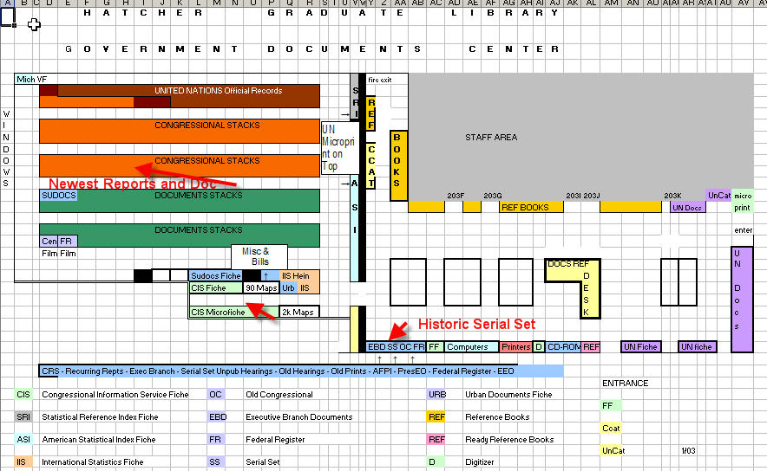

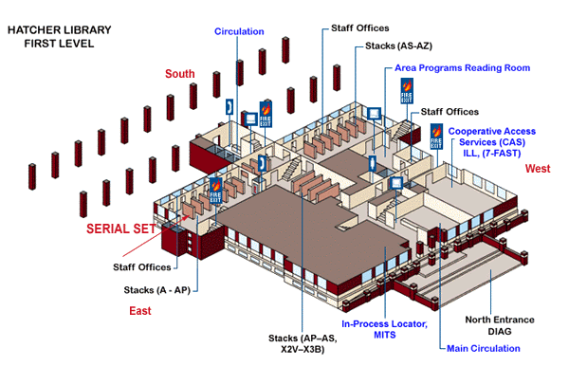

Practice Questions

- What is the Serial Set Number of Senate Miscellaneous Document 42 of the 40th Congress, 2nd session? Where is the paper copy? Can you physically
find the microfiche copy?

- Identify the House Report on H.R. 476, the Michigan Scenic Rivers Act,
102nd Congress, 1991-92. What is the Serial Set number for the paper, and where is it located? What is the CIS number for the microfiche, and where is it located?

- Identify the House committee report on the expulsion of Representative Bud
Shuster. It was held within the past five years. Can you find it on the Documents Center shelves? If not, what is the CIS microfiche number?

ANSWERS

1319. Use CIS Serial Set Finding Lists
(Docs. Z 1223 .Z7 C764 1975 pt. 2, v.3) You can request the paper from Buhr using the call number: Document 1319. It is also on microfiche in the Documents Center under that number.

Use Congressional Universe (CIS Index) by bill number to determine the report number as H.Rpt. 102-84. Fiddle with and use the Numerical List (Docs. Z 1223.A15) to determine the Serial Set Number: 14074. The CIS microfiche number should appear on the original Congressional Universe Record as: 91-H443-11. This is located in the Documents Center.

Use Congressional Universe (CIS Index) by
subject number to determine the report number as H.Rpt. 106-979 and the SUDOCS Number Y 1.1/8:106-979. This should be on the
Documents shelves. If not, the CIS number
is 2000-H743-1

Government Documents Center Help Guide Series
Developed by: Lauren M. Collins, Esq., Masters Candidate
University of Michigan, School of Information
Grace York, Coordinator, Documents
University of Michigan Library
May 2003 – revised May 2008

