regions / groups of organizations reform proposals
Finance

Names: Joseph Green, Luis Siqueira, Jose Stevenson

Region / Group of Organizations: Advocacy NGO’s

1. How much money is needed for the Global Fund to be effective in addressing the current global AIDS crisis?

In order to obtain the $10 billion per year necessary to adequately finance the Global Fund, we believe that all Organization for Economic Cooperation and Development (OECD) member countries should contribute an amount to the Fund as attained by the following equation:

Country’s 2000 GNP / (Total OECD’s 2000 GNP) * $10B

We also call for full participation from all 30 OECD countries, whereas, currently, 6 have not donated any amount.

2. Should the U.N. require mandatory contributions from United Nations member states to support the Global Fund? If so, how should the Fund determine the appropriate assessment on each individual country?

Yes, the U.N. should require mandatory contributions from United Nations member states to support the Global Fund.

We believe that mandatory contributions should be dictated by the above equation, which will result in the following allocations:

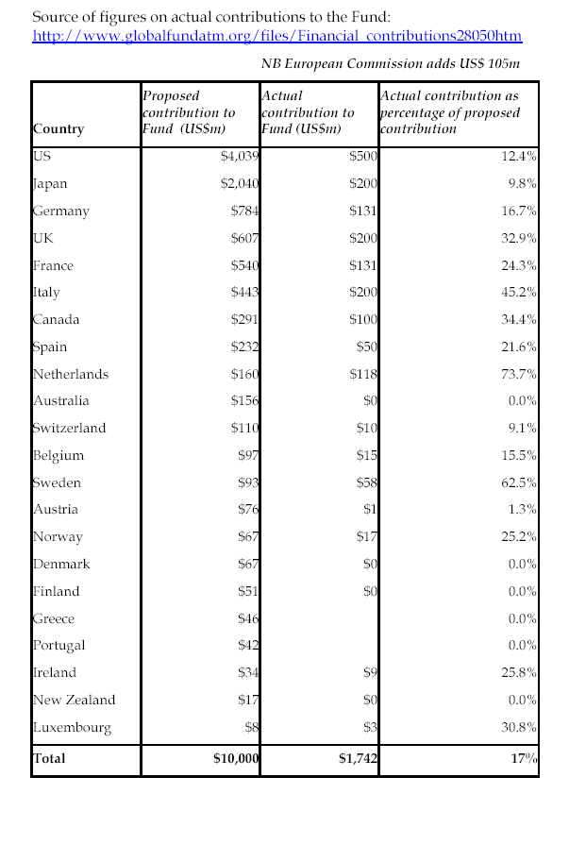

3. As an alternative to assessments on member countries, should the U.N. mandate some form of global tax on certain types of economic activity or financial transaction. If so, what sort of tax should it be?

We are open to financing the Fund with a small tax for pharmaceutical patents in developing countries. The idea of global taxes has been debated for decades, but has been largely ignored by countries as a feasible means of generating revenue. We feel further research in this area is necessary.

We also believe that debt refinancing or forgiveness for poor countries will increase their ability to fight HIV/AIDS through local initiatives.

4. If it does not impose mandatory assessments or taxes, how should the required resources required for the Fund be raised? Voluntary contributions from member states? Grass-roots fundraising? Public-private partnerships?

We believe that it is imperative that contributions from member states remain mandatory. If not, the Fund will find itself in a predicament similar to that in which it finds itself today, where less than one fifth of the funding needed to combat the global HIV/AIDS epidemic has been secured.

Regardless, the Fund should remain open to all voluntary contributions from any source, whether member states, grass-roots or public-private partnerships.

5. What specific measures can the Fund take to encourage greater financial support from the public and private sectors?

Private sector contributions have lagged behind their anticipated levels. Therefore, we believe that it is important to encourage donations from this sector. One method would be to license sponsorships to be used by the donating corporation for advertising purposes, e.g. labeling of products.

6. Any additional agenda issues/solutions?

None.

regions / groups of organizations reform proposals
Targeting

Names: Xerxes (Gates Fdn), Kathleen Mogelgaard (Oxfam), Nahoko Maeda (Oxfam),
Sungjoo Choi (Catholic Bishops), Jennifer Cheng (ACT UP)

Region / Group of Organizations: Advocacy NGOs

1. Should the Global Fund be used to address the HIV/AIDS crisis only in the world's poorest countries? Or should it also fund activities and programs in middle income and/or OECD countries as well?

The Global Fund should prioritized marginalized groups by funding programs for the worlds’ poorest countries (LDCs) and middle income countries that have need through the criteria listed below. OECD countries should have enough resources that do not call for help from the Global Fund. UNAIDS should also be careful to have a fair distribution of funds such that funding is not disproportionately concentrated in one region at the cost of other regions in need. Additionally, some population groups may cross national boundaries such that we advocate that UNAIDS continue to develop Regional CCMs in coordination with National CCMs.

Since there are often marginalized groups within middle income countries that are not addressed through existing programs, the Global Fund has a responsibility to these vulnerable populations. (Indigenous groups, street children, and other marginalized groups that are not often captured in statistics should not be neglected in program development or service delivery). Criteria for funding of programs in middle income countries should include a combination of these factors:

- % of population that is infected with HIV
- growth rate of infection
- lack of infrastructure
- HIV infection and growth rates of marginalized groups within the country/region

2. Does it make more sense for the Fund to target specific groups with its limited resources to maximize impact? Please justify answer.

It does make more sense for the Global Fund to target specific groups in order to reach vulnerable populations. Targeting, a strategy proven in many studies, reaches people better when programs are better tailored to communicate prevention and treatment ideas. Cultural, gender, class, and other group sensitivities are needed to spend the money wisely on effective programs.

3. If “targeting” is used, what groups should the Fund target?
- Demographic groups, such as: men, women, children, young people, pregnant women and their infants, mothers, economically active population, etc?
- Occupational groups, such as: health care workers, teachers, policeman, prostitutes, truck drivers, etc
- Other vulnerable populations, such as: intravenous drug users, prisoners, migrant populations, men who have sex with men, people living under armed conflict, etc
Please outline a targeting strategy, if appropriate, such as prioritizing groups in a particular order. Also, provide a percentage breakdown of how you would allocate Fund resources to your targeting strategy.

We advocate a targeting strategy focuses primarily on prevention and treatment (as consistent with the advocacy organizations’ program activities proposal). We believe that the money spent from the Global Fund needs to focus on delivering services to people. Programs are often based on monies spent, however, we advocate that the Fund measure its services delivered by looking at who they are reaching. While there are many groups who are affected by HIV/AIDS, we believe that priorities must be made to vulnerable populations.

Targeting considerations should be made on a country and regional level with the following questions:

- Who is “forgotten” in existing programs?
- Who does not have political power and would lack services from the government and existing institutions?
- Who are the populations most impacted?
- Who spreads the disease and are involved in high-risk behavior?

In this respect, out of the $10 billion that is proposed, we advocate that at least 75% of the recipients be people in the following groups that we define “vulnerable populations” prioritized in the following order:

- Women
- Sex workers (formal or informal prostitutes)
- Youth
- Orphans/children
- Men who have sex with men (who may or may not identify as “homosexual” or “bisexual” depending on local cultural norms)
- Victims of abuse and violent conflicts (includes children who have been abused and victims of war)
- Migrant workers (truck drivers, sailors, and other laborers who travel for their work)
- Intravenous drug users
- Prisoners (who are often abused, raped, and receive limited or no health care)
- Others involved with high risk behavior

We believe the remaining 25% is sufficient to provide programs that serve teachers, health educators, and other groups who are helpful in preventing and reaching local communities. The request for at least 75% of recipients of Fund services to be vulnerable populations is an important provision to maintain a focus on groups who would be most disadvantaged in accessing services.

REGIONS/GROUPS OF ORGANIZATIONS REFORM PROPOSALS
PROGRAM/ACTIVITY AREA

Names: Amber Arellano, Aron Boros, Veronica Richardson, Robert Young
Region/Group of Organizations: Advocacy NGOs

- Which program or activity areas should the Global Fund focus on: prevention, treatment, vaccines, or some combination? Please justify strategy and provide supporting evidence of effectiveness of proposed solution.

We recognize the critical importance of the rapid development of a vaccine, however, we believe that Global Fund monies should be distributed to treatment and prevention activities because of the immediate threat to the institutions and societies of the most affected areas.

Due to this immediate threat, we propose funding for programs and activities to be largely allocated towards prevention and treatment which will get 45% of funding each with no more than 5-10% of funding dedicated towards vaccination research.

- How would you design implementation and delivery mechanisms for the chosen programs/activities in order to maximize their effectiveness? Be sure that your responses to both (1) and (2) are sensitive to economic, cultural, and infrastructure issues.

Vaccination Research
Money dedicated towards vaccination research by the Global Fund is to be directed solely towards countries targeted by the Fund who could use the money for such efforts as vaccine trials or development of delivery mechanisms in affected countries.

Prevention
In addition to the criteria set forth by UNAIDS, we call for the following criteria by which programs should be evaluated:
- Demonstration of a high level of local knowledge, with an analysis of how the proposed strategies will work effectively within local communities. Alliances and coalitions with existing local groups are particularly important. These local programs must demonstrate consistency with regional and national strategies.
- Mainstreaming women’s issues within all programs. A gender analysis of the effect of the proposal must be performed, regardless of whether or not women’s issues are explicit goals of the proposal. Particular consideration will be given to proposals that work towards lasting changes to institutional structures that disadvantage women.
- In general, proposals should address underlying cultural behaviors and institutions that exacerbate the spread of AIDS.

In addition to the above prevention efforts, we are calling for the creation of a network of information exchange to disseminate best practices between prevention, treatment, and care organizations worldwide.

- Any additional agenda issues/solutions?
We would like to reiterate the importance of evaluation structures and financial transparency.
regions / groups of organizations reform proposals
Intellectual Property rights

Names: Matt Alpert (Oxfam), Robert Cordova (Gates), Philip Maxwell (Catholic Bishops)

Region / Group of Organizations: Advocacy NGOs

- Should developing countries be granted a particularly generous interpretation of the multilateral agreement on protection of intellectual property (TRIPS) to allow them to manufacture or import inexpensive generic versions of patented drugs and thus reduce the cost of Global Fund programs?
- Should developing countries be granted a complete waiver of patent protection provisions for all AIDS medications, both existing and yet to be developed? Or should some limitations be imposed to provide incentives for further research and innovation in that field? In short, how would you implement any waiver arrangements?

The Advocacy NGOs seek to ensure that people in developing countries have access to the most effective drugs on the market, at prices that allow these treatments to be widely afforded. The Forum must reaffirm the primacy of public health over intellectual property rights, as stated in the Doha Declaration on TRIPS and Public Health. To best achieve this goal, the Advocacy NGOs demand that the WTO waive patent regulations on AIDS medications for developing nations, or at least support a continued generous interpretation of the TRIPS agreement.
While Research and Development is necessary to create an AIDS vaccine, the current crisis in the developing world needs immediate attention. We feel that our first and foremost goal is to treat those currently living with the disease, and increase the quality of and length of their lives. This can best be achieved through drugs that currently exist but are not readily available to those who need them the most.
Specifically, the Fund should issue a clear statement that the proposals it receives can use the TRIPS public-health safeguards, reaffirmed in the Doha Declaration, to purchase and create generic medicines. In addition, a resolution must be reached to allow for the exportation of generic AIDS drugs to developing countries. Currently, TRIPS allows for compulsory licensing in health emergencies only if the license is predominantly used for domestic markets. Unfortunately, the countries that need these drugs most do not have the ability to produce them, and must import them from abroad. Already, many of these exporters, including developed nations such as Canada, cannot export these generic drugs. In addition, the few developing nations who can still export these much-needed medications must come into compliance with the TRIPS agreement by 2005. A resolution providing exceptions to this rule for AIDS medicines will positively affect nations that are currently being destroyed by this disease. At this time, even the United States has stated that it will not stand in the way of amending these practices with regard to AIDS drugs, so this is an attainable goal.

Please see below for the Gates Foundation’s Dissenting Opinion

3. How would you define “developing countries” for this purpose Would you extend the provisions you have designed to countries that to do not meet the definition of “developing” but are experiencing or threatened by a major AIDS epidemic?

We define developing nations as those nations recognized by the WTO as such, or recognized by said organization as a “Least Developed Country.” Moreover, we will allow the Fund to extend these provisions to nations that are considered “at-risk” by the Global Fund (e.g. India).

4. Any additional agenda issues/solutions?

We believe that an education campaign, informing developing nations of their rights with regard to intellectual property and health emergencies, will result in increased awareness and use of parallel importation, and other legal but underused strategies.

After serious and protracted negotiations, there remain certain philosophical differences between the Gates Foundation and the other Advocacy NGOs. The following is their statement of dissent on the first two questions.

1. No. The Gates Foundation has a generous wallet and a mindful ideology. Bill Gates has always been a firm believer in the supremacy of patents and intellectual property law. The foundation sees no need to completely subvert the motivating force that well delineated property laws provide. In fact, it has gone to great lengths to ensure vaccines are available to poor countries and patents are observed. For instance, it has devoted 100 million dollars to the International AIDS Vaccine Initiative to help develop vaccines within a patent observant context. Thus, the Gates Foundation supports a tiered pricing mechanism to charge poorer countries less money. It will also back this policy up buy provide funding to these countries to purchase these vaccines.

To undermine patents is to undermine a motivating force to future health and scientific progress.

2. No waivers. We would rather pay for the vaccines on behalf of developing nations.

