- ISLAMIC EXTREMISM -  FUELS THE CAMPAIGN  AGAINST ISRAEL  The decrees of Sheikh Muhammad Sayyed Tantawi, the top Egyptian cleric of Al Azhar University, were recently presented at a reception for Israeli Arab leader Abd Al Wahhab AlDarawshe, published  April 4, 2002  "The great Imam of Al Azhar Sheikh Muhammad Sayyed Tantawi, demanded that the Palestinian people, of all factions, intensify the martyrdom operations [i.e. suicide attacks] against the Zionist enemy…[Sheikh Tantawi] emphasized that every martyrdom operation against any Israeli, including children, women, and teenagers, is a legitimate act according to [Islamic] religious law, and an Islamic commandment…"  Egypt's new mufti, Sheikh Dr. Ahmad Al Tayyeb, has since also expressed his support for suicide attacks.  "…the solution to the Israeli terror lies in a proliferation of Fidai [martyrdom] attacks that strike horror into the hearts of the enemies of Allah. The Islamic countries, peoples and rulers alike, must support these martyrdom attacks."  Is it really about “occupation”? Is appeasement the answer? Read other translations of Arab media at www.memri.org, or learn about media bias against Israel at www.honestreporting.com. Brought to you by MSZ. | - ANTI-SEMITISM -  FUELS THE CAMPAIGN  AGAINST ISRAEL  The following are excerpts from a Friday sermon delivered by Palestinian Authority Imam Sheikh Ibrahim Madhi at the Sheikh ‘Ijlin Mosque in Gaza City, broadcast live on Palestinian Authority TV:  April 12, 2002  “We are convinced of the [future] victory of Allah; we believe that one of these days, we will enter Jerusalem as conquerors, enter Jaffa as conquerors, enter Haifa as conquerors, enter Ramle and Lod as conquerors, the [villages of] Hirbiya and Dir Jerjis and all of Palestine as conquerors, as Allah has decreed… ‘They will enter Al-Aqsa Mosque as they have entered it the first time…’”  “Anyone who does not attain martyrdom in these days should wake in the middle of the night and say: ‘My God, why have you deprived me of martyrdom for your sake? For the martyr lives next to Allah’…”  “Oh Allah, accept our martyrs in the highest heavens…”  ”Oh Allah, show the Jews a black day…”  ”Oh Allah, annihilate the Jews  and their supporters…”  ”Oh Allah, raise the flag of Jihad across the land…”  Is it really about “occupation”? Is appeasement the answer? Read other translations of Arab media at www.memri.org, or learn about media bias against Israel at www.honestreporting.com. Brought to you by MSZ
- ARAB MEDIA INCITEMENT -  FUELS THE CAMPAIGN  AGAINST ISRAEL  In the Saudi government-controlled daily Al-Jazirah, columnist Dr. Khalil Ibrahim Al-Sa'adat applauded the actions of 'Abd Al-Baset 'Oudeh, who detonated himself at a Passover Seder in a Netanya hotel, and Ayat Al-Akhras, who bombed a Jerusalem supermarket.  April 1, 2002  "May Allah have mercy upon you, oh 'Abd Al-Baset 'Oudeh, mujaheed and martyr, the quiet hero who infiltrated so elegantly and spoke so gaily. You defended your religion, your homeland, and your people.”  "Despite all the obstacles, fortifications, and security measures, you…sat down at one of the tables, talked, told a few jokes, and laughed with them, and then Allah decreed for you a martyr's death. What heroism, courage, and strength – almost unmatched on the face of the earth!"  "May Allah have mercy on you, oh Ayat Al-Akhras. You left your home for the path of martyrdom and Paradise… You proceeded with a determination, will, and strength rarely found, even impossible to find, in a 16-year-old girl…"  Is it really about “occupation”? Is appeasement the answer? Read other translations of Arab media at www.memri.org, or learn about media bias against Israel at www.honestreporting.com. Brought to you by MSZ. | - THE REWRITING OF HISTORY -  FUELS THE CAMPAIGN  AGAINST ISRAEL  The following are excerpts from an article by Fatma Abdallah Mahmoud titled "Accursed Forever and Ever," which appeared in the Egyptian government daily Al-Akhbar  May 3, 2002  "[Jews] are…the plague of the generation and the bacterium of all time. Their history always was and always will be stained with treachery, falseness, and lying. Historical documents prove it."  "With regard to the fraud of the Holocaust… Many French studies have proven that this is no more than a fabrication, a lie, and a fraud!! That is, it is a 'scenario' the plot of which was carefully tailored, using several faked photos completely unconnected to the truth…I, personally… complain to Hitler, even saying to him from the bottom of my heart, 'If only you had done it, brother.'"  "Basically, they are a model of moral ugliness, debasement, and degradation. If only Allah would curse them more and more, to the end of all generations. Amen."  Is it really about “occupation”? Is appeasement the answer? Read other translations of Arab media at www.memri.org, or learn about media bias against Israel at www.honestreporting.com. Brought to you by MSZ.

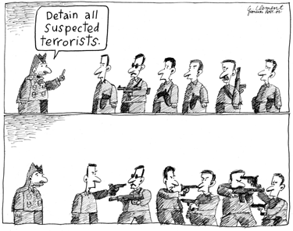  Suicide bombings are not the product of “occupation” but part of a larger strategy of applying pressure through terrorism adopted by the Palestinian Authority. Yasser Arafat has persistently diverted funds meant for humanitarian aid and economic growth into terrorist attacks, a strategy that keeps his people poor and desperate in order to 1) facilitate a steady stream of suicide bombers and 2) exploit sympathy in the West.  The “root causes” of suicide bombings are anti-semitism, Islamic extremism, Arab government and media incitement, and the belief that terrorism will translate into concessions leading to a vulnerable Israel.  Fighting terrorism head on is the surest way to help the Palestinian people. The Palestinian leadership has not decided between having a state and ending terrorism; instead, they want both. A unilateral Israeli withdrawal would result in a dictatorship that would serve as a contiguous base of terrorism, in essence, another Afghanistan.  To get involved, visit www.umich.edu/~zionists  or e-mail msz-info@umich.edu | 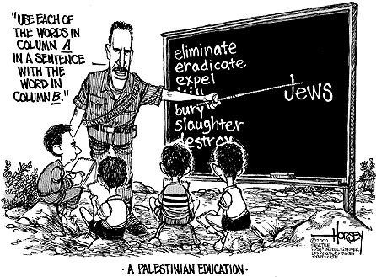  Suicide bombings are not the product of “occupation” but part of a larger strategy of applying pressure through terrorism adopted by the Palestinian Authority. Yasser Arafat has persistently diverted funds meant for humanitarian aid and economic growth into terrorist attacks, a strategy that keeps his people poor and desperate in order to 1) facilitate a steady stream of suicide bombers and 2) exploit sympathy in the West.  The “root causes” of suicide bombings are anti-semitism, Islamic extremism, Arab government and media incitement, and the belief that terrorism will translate into concessions leading to a vulnerable Israel.  Fighting terrorism head on is the surest way to help the Palestinian people. The Palestinian leadership has not decided between having a state and ending terrorism; instead, they want both. A unilateral Israeli withdrawal would result in a dictatorship that would serve as a contiguous base of terrorism, in essence, another Afghanistan.  To get involved, visit www.umich.edu/~zionists  or e-mail msz-info@umich.edu
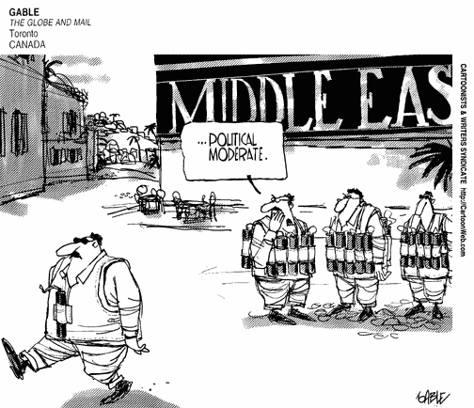  Suicide bombings are not the product of “occupation” but part of a larger strategy of applying pressure through terrorism adopted by the Palestinian Authority. Yasser Arafat has persistently diverted funds meant for humanitarian aid and economic growth into terrorist attacks, a strategy that keeps his people poor and desperate in order to 1) facilitate a steady stream of suicide bombers and 2) exploit sympathy in the West.  The “root causes” of suicide bombings are anti-semitism, Islamic extremism, Arab government and media incitement, and the belief that terrorism will translate into concessions leading to a vulnerable Israel.  Fighting terrorism head on is the surest way to help the Palestinian people. The Palestinian leadership has not decided between having a state and ending terrorism; instead, they want both. A unilateral Israeli withdrawal would result in a dictatorship that would serve as a contiguous base of terrorism, in essence, another Afghanistan.  To get involved, visit www.umich.edu/~zionists  or e-mail msz-info@umich.edu | 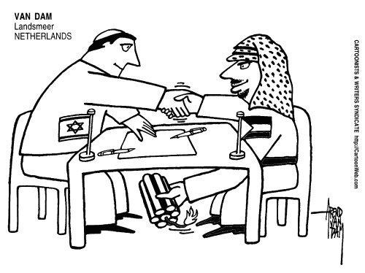  Suicide bombings are not the product of “occupation” but part of a larger strategy of applying pressure through terrorism adopted by the Palestinian Authority. Yasser Arafat has persistently diverted funds meant for humanitarian aid and economic growth into terrorist attacks, a strategy that keeps his people poor and desperate in order to 1) facilitate a steady stream of suicide bombers and 2) exploit sympathy in the West.  The “root causes” of suicide bombings are anti-semitism, Islamic extremism, Arab government and media incitement, and the belief that terrorism will translate into concessions leading to a vulnerable Israel.  Fighting terrorism head on is the surest way to help the Palestinian people. The Palestinian leadership has not decided between having a state and ending terrorism; instead, they want both. A unilateral Israeli withdrawal would result in a dictatorship that would serve as a contiguous base of terrorism, in essence, another Afghanistan.  To get involved, visit www.umich.edu/~zionists  or e-mail msz-info@umich.edu

